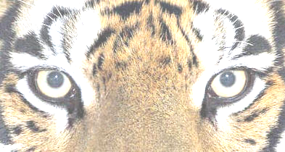
Home | Students | Clubs | Departments | Guidance | Events | Staff
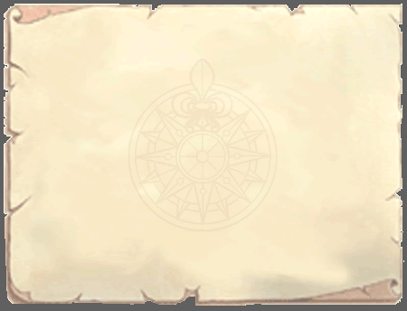
======================
Home
======================
News
Opinion
Entertainment
Sports
Art
Photography
Fun Stuff
======================
Search
[=======][Go]
======================
Members
FAQ
About Us
Contact Us

Recent News

>> Scrollin <<
>> Thingy <<
>> Movin Up <<

Featured Article
(Title)
(Title)

Popular Articles
(Title)
(Title)
(Title)
(Title)

Archives
Month, Year
Month, Year
Month, Year
Month, Year
Month, Year
Month, Year

Welcome!
Welcometo Thornhill Secondary School’s newsletter group, Eye of the Tiger, blah blah blah. Insert more text here. Also include “Why should I help” (because you want to combat world hunger and AIDS. Also because there will be better reasons here).

How can I help/What to write?
Tons of stuff to write about, like @#$%,. @#$%, @#$%, … etc. More text here. And will be a very thorough and convincing explanation.
==============================================
News and Announcements

Interesting info here
~ Admin’s name, Date
[Read more] [Comments ##]

More interesting info here
~ Admin’s name, Date
[Read more] [Comments ##]

==============================================
Recent Articles

Title of article
Brief description/first paragraph…
[Read more] [Comments ##]

Title of article
Brief description/first paragraph…
[Read more] [Comments ##]

Title of article
Brief description/first paragraph…
[Read more] [Comments ##]

Title of article
Brief description/first paragraph…
[Read more] [Comments ##]


Opinions
Home | Students | Clubs | Departments | Guidance | Events | Staff
======================
Home
======================
News
Opinion
Entertainment
Sports
Art
Photography
Fun Stuff
======================
Search
[=======][Go]
======================
Members
FAQ
About Us
Contact Us

Student Opinions Matter!
This is the opinions section, where students get to “voice their opinions”, or at least air cat fights in the form of very “persuasive” essays. Et cetera.
===================================================================
Popular Articles

Title of article
Brief description/first paragraph…
[Read more] [Comments ##]

Title of article
Brief description/first paragraph…
[Read more] [Comments ##]

=================================================================
One on One

Title of article
Brief description/first paragraph…
[Read more] [Comments ##]

Title of article
Brief description/first paragraph…
[Read more] [Comments ##]

=================================================================
Recent Articles

Title of article
Brief description/first paragraph…
[Read more] [Comments ##]

Title of article
Brief description/first paragraph…
[Read more] [Comments ##]

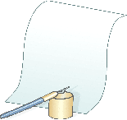
Article
======================
Home
======================
News
Opinion
Entertainment
Sports
Art
Photography
Fun Stuff
======================
Search
[=======][Go]
======================
Members
FAQ
About Us
Contact Us

Title of Article
By Mr. Author, Date, Issue #
[Viewed ## of times, Left ## of comments] <- skip link to the comments section

Blah blah blah blah blah blah blah blah blah blah blah blah blah blah blah blah blah blah blah blah blah blah blah blah blah blah blah blah blah blah blah blah blah blah blah blah blah blah blah blah blah blah blah blah blah blah blah blah blah blah blah blah blah blah blah blah blah blah blah blah blah blah blah blah blah blah blah blah blah blah blah blah blah blah blah blah blah blah blah blah blah blah blah blah

Blah blah blah blah blah blah blah blah blah blah blah blah blah blah blah blah blah blah blah blah blah blah blah blah blah blah blah blah blah blah blah blah blah blah blah blah blah blah blah blah blah blah blah blah blah blah blah blah blah blah blah blah blah blah blah blah blah blah blah blah blah blah blah blah blah blah blah blah blah blah blah blah blah blah blah blah blah blah blah blah blah

Therefore, blah blah blah blah blah blah blah blah blah blah blah blah blah blah blah blah blah blah blah blah blah blah blah blah blah blah blah blah blah blah blah blah blah blah blah blah blah blah blah blah blah blah blah blah blah blah blah blah blah blah blah blah blah blah blah blah blah blah blah blah blah blah blah blah blah blah blah blah blah blah blah blah. FTW

==============================================================
[View comments] <- javascript thingy that makes comments appear

| “Reply Title” by Username on Date
| Here are my comments, hear hour mai commrads.
|
| “Reply Title” by Username on Date
| Here are my comments, hear hour mai commrads.

==============================================================
Post Reply
Title: [==============================================================]
Username: [==============================================================]

Home | Students | Clubs | Departments | Guidance | Events | Staff
Insert comments here
Reset
Reset

