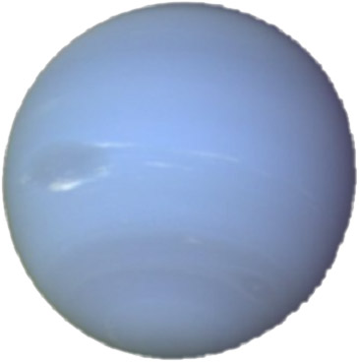
eptune
N
ψ
−

By Philip Peng

For Mr. Body

SPH4U1

2008/05/19

Statistics

Mass 1.02 x 10²⁶ kg

Diameter 49528 km

Mean density 1640 kg/m3

Escape velocity 23300 m/s

Equatorial surface gravity 11.15 m/s²

Average distance
from Sun 30.07 AU
Perihelion 29.77 AU
Aphelion 30.44 AU
Rotation period 0.67 days
Revolution period 60,190 days
Obliquity 29.6o
Orbit inclination 1.77o
Orbit eccentricity 0.009
Orbital speed 5.43 km/s

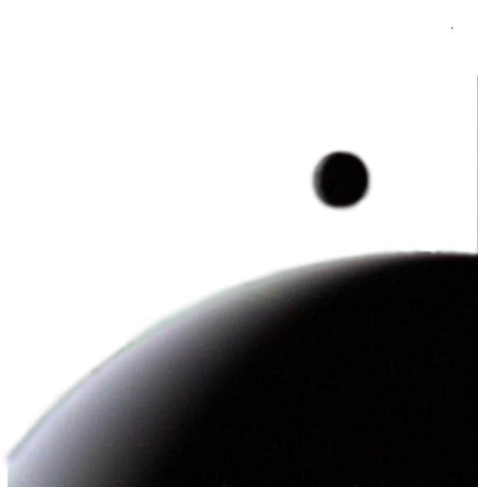

Composition

Mean temperature 48 K
Visual geometric albedo 0.51

Rings:
Rings are narrow, and contain concentrations of particles called ring arcs.

Atmospheric components:
74% hydrogen, 25% helium, 1% methane (at depth)

Mantle:
Water, ammonia, methane ices

Core:

Rock, ice

Moons:
13 known moons, the largest of which is Triton (above right)

Background:

Neptune is the eighth and farthest planet from the Sun (after the demotion of Pluto to a dwarf planet status) in our Solar System. It is the Solar System’s fourth largest by diameter and third largest by size. Like Jupiter, Saturn and its neighbour Uranus, Neptune is a gas giant. In its southern hemisphere, Neptune has a Great Dark Spot (centre left in the above picture taken by NASA’s Voyager 2 space probe in its 1989 flyby) similar in appearance to Jupiter’s Giant Red Spot.

History:

Neptune was discovered following careful mathematical calculations by Urbain Le Verrier after it was hypothesized that there existed an unknown body causing the perturbations of Uranus’ orbit. Neptune was discovered on September 23, 1846 by the astronomer Johann Gottfried Galle, assisted by Heinrich d'Arrest, through the Berlin Observatory within 1º of Le Verrier’s prediction.

Naming:

At first Neptune was referred to as “Le Verrier’s planet” or just “the planet exterior to Uranus”. After debates between the English and French, the name Neptune was internationally accepted. In Roman mythology, Neptune was the god of the sea (thus Neptune’s stylized trident as its astronomical symbol), following the Roman god nomenclature of the other planets (except for Earth and Uranus).
Web Sources:

NASA/JPL Planet Profile:
http://pds.jpl.nasa.gov/planets/special/neptune.htm

Wikipedia Article:
http://en.wikipedia.org/wiki/Neptune

Picture Sources:

Neptune via Voyager 2:
http://voyager.jpl.nasa.gov/image/images/neptune/neptunex.gif

Neptune and Triton via Voyager 2: http://voyager.jpl.nasa.gov/image/images/neptune/20bg.jpg

Statistics

Mass 1.02 x 10²⁶ kg

Diameter 49528 km

Mean density 1640 kg/m3

Escape velocity 23300 m/s

Equatorial surface gravity 11.15 m/s2

Orbit and Rotation

Average distance from Sun 30.07 AU

Perihelion 29.77 AU

Aphelion 30.44 AU

Rotation period 0.67 days

Revolution period 60,190 days

Obliquity 29.6º

Orbit inclination 1.77º

Orbital Speed 5.43 km/s

Orbit eccentricity 0.009

Composition

Mean temperature 48 K
Visual geometric albedo 0.51

Rings are narrow, and contain concentrations of particles called ring arcs.

Atmosphrere is composed of approximately 74% hydrogen, 25% helium, 1% methane (at depth)

Mantle is composed of: water, ammonia, methane ices. Core is composed of rock and ice.

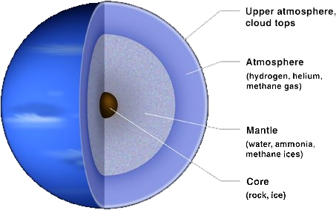

Layers of Neptune

Background & History:
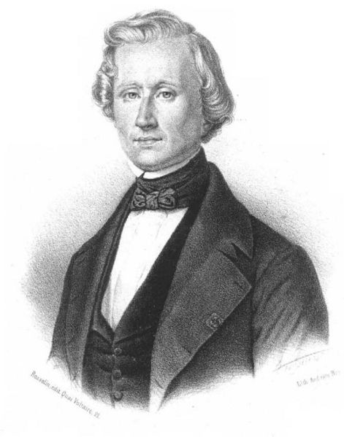
Neptune is the eighth and farthest planet from the in our Solar System. A gas giant with the fourth largest diameter in our Solar system, Neptune is the third largest planet. In its southern hemisphere, Neptune has a Great Dark Spot. Neptune was first discovered following careful mathematical calculations by Urbain Le Verrier. Astronomer Johann Gottfried Galle confirmed its location on September 23, 1846. In Roman mythology, Neptune was the god of the sea. Thus Neptune’s stylized trident as its astronomical symbol.

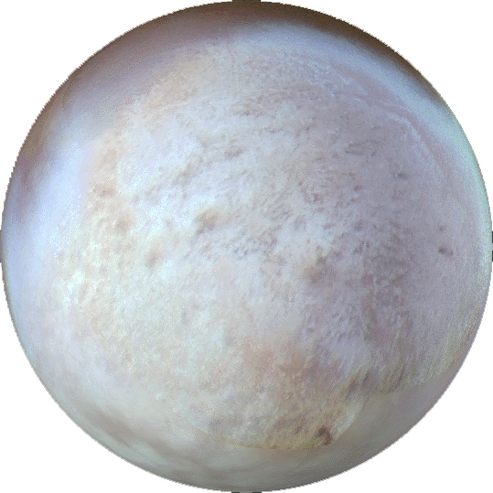
Moons
Neptune has a total of 13 moons. The largest of them is Triton, which is suspected to be a Kuiper Belt object captured by Neptune’s gravity. It is of similar composition to the dwarf planet Pluto.

