The Colosseum By Philip Peng

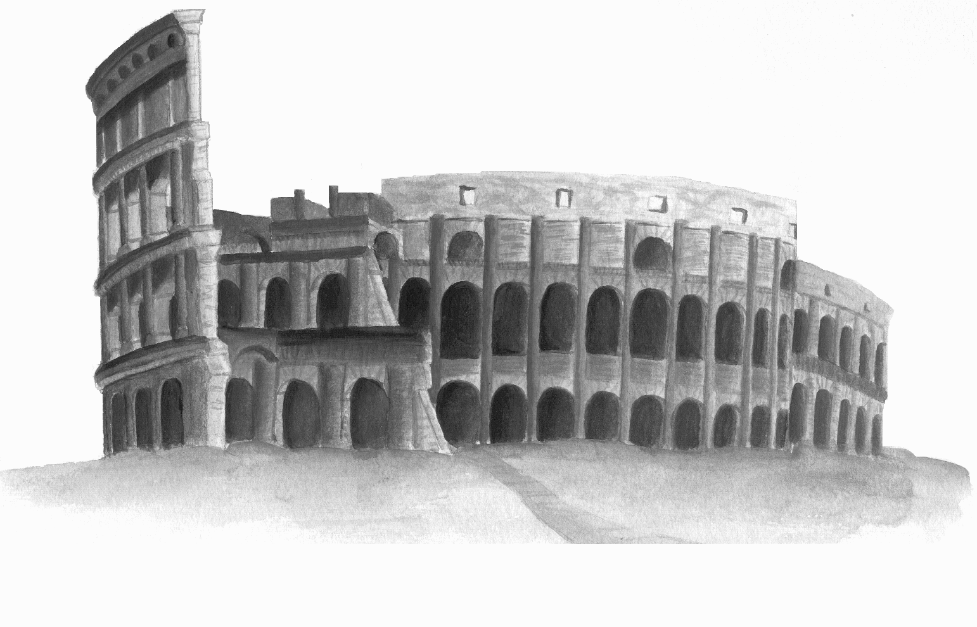The Colosseum, one of the greatest, surviving ancient architecture, was started under the orders of Emperor Vespasian in 72 AD. After 12 years of toiling and labour by workers and slaves, his son, Domitian, finished it in 80 AD. After its completion, a 100-day opening celebration followed, where thousands of wild animals and humans were sent out to fight or be slaughtered.
The Colosseum was the first, large scale, permanent amphitheatre, a round, open theatre used for showing sports, games, and displays, most of which were often bloody and shown to the public for their entertainment. It was built in the heart of the Roman Empire, the Mediterrancean climate of Rome in Italy, also once known as the Capitol. The building itself was built at the site of Nero’s palace, the Domus Aurea. The original, proper name was the Flavian Amphitheatre, named after the Flavian Dynasty that built it. However, it was more commonly known as the Colosseum due to the “colossus” 40-metre statue of Nero nearby.
The main purpose of the Colosseum was to entertain the public. The shows often displayed gladiators, specially trained fighters, usually slaves, prisoners, or prospectors, who fought until death, fighting, wild animal hunts, prisoner killings by animals, naval battles, and other bloody sports. In total, an estimated over 500 000 humans and animals died there.
The Colosseum is one of the most impressive structures still standing, being 48 metres high, 188 metres wide and 156 metres long with an elliptical shape to prevent players from going into corners while allowing spectators a closer view. The structure had a base of equivalent of 160 000 m², and underneath the entire structure were cement vaults designed to hold the fighters, prisoners, and animals. A system of pulleys and ramps was used to lift them up from underneath, as if appearing from the ground. In addition, there was a heating and cooling system underneath to keep the spectators nice and comfortable. The levels of the Colosseum had different columns to reflect class: the first story was Doric, the second Ionic, and the third Corinthian.
The building itself was mainly made from limestone or concrete. Travertine limestone quarried from Tibur, today Tivoli, was used for the main pillars, while tufa was used for the other pillars. Ceramic tiles were used for the floors and the walls and the vaults were made from strong concrete, usually made from mixing limestone clay and a rocks or pebbles of various size depending on the concrete’s use.

