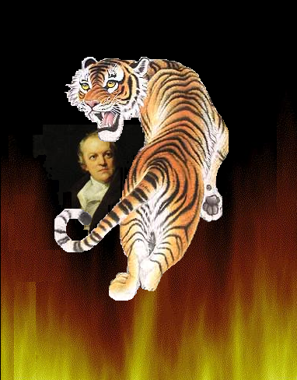
Tiger Tiger. burning bright,
In the forests of the night;
What immortal hand or eye.
Could frame thy fearful symmetry?
In what distant deeps or skies.
Burnt the fire of thine eyes?
On what wings dare
he aspire?
What the hand, dare
seize the fire?

And what shoulder,
& what art,
Could twist the sinews
of thy heart?
And when thy heart
began to beat
What dread hand? &
what dread feet?

What the hammer?
what the chain,
In what furnace
was thy brain?
What the anvil?
what dread grasp.
Dare its deadly
terrors clasp?

When the stars threw
down their spears
And watered heaven
with their tears:
Did he smile
His work to see?
Did he who made the
lamb make thee?
Tiger Tiger. burning bright,
In the forests of the night;
What immortal hand or eye.
Could frame thy fearful symmetry?
The Tiger
- By Williams Brake
Tiger Tiger. burning bright,
In the forests of the night;
What immortal hand or eye.
Could frame thy fearful symmetry?
In what distant deeps or skies.
Burnt the fire of thine eyes?
On what wings dare
he aspire?
What the hand, dare seize the fire?

And what shoulder,
& what art,
Could twist the sinews
of thy heart?
And when thy heart
began to beat
What dread hand? &
what dread feet?

What the hammer?
what the chain,
In what furnace
was thy brain?
What the anvil?
what dread grasp.
Dare its deadly
terrors clasp?

When the stars threw
down their spears
And watered heaven
with their tears:
Did he smile
His work to see?
Did he who made the
lamb make thee?

