Operation 24
Created Philip Peng and Jonathan Cheng
Goal:
Using the BEDMAS operation cards, create a final result of 24.

Rules:
?
?
?
?
+
-
×
÷
(
- Draw four cards and place them where all players can see.
- Each player mentally tried to create a result of 24 using the values of the four cards and the four operations [addition, subtraction, multiplication, division].
- When one player finds a way to create 24, they shout, “24!”
- All players must stop and that player must rearrange the four cards and, using the BEDMAS operation cards, show the correct equation creating 24.
- If the result is correct, then that player is the winner of the round. If another player finds a fault in equation, then the person who finds the fault first wins the round instead.
- Once the points have been tallied, the four cards should be shuffled back into the deck, and four new cards drawn for the next round.
- Enjoy the game!!! ; )

Time Limit n’ Point System:
The time limit for each round is 1 minute. If a player correctly creates a sequence resulting in 24, then that player receives 3 points. If not, at the end of the 1 minute, the player who has a result closest to 24 (but not over!) receives 1 point. If more than one player gets the same total or equation, then no one gets any points. Points are tallied at the end of each round.

Card Values:
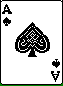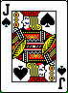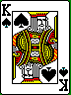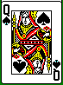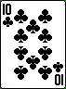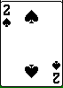
to
= face value
1
11
12
13

